|  |  |
| --- | --- |
| **[Project] – External Document** |  |
| <COMP6176>  <Human and Computer Interaction> |
| [Even] Semester Year 2020/2021 |

* Project Title

Store Del Luna

* Introduction

Pada projek ini, kelompok kami membuat sebuah website Store Del Luna. Store Del Luna merupakan supplier merchandise dan album-album K-Pop yang terkenal. Pada website ini, user dapat membeli album-album dan merchandise dari artis K-Pop favorit mereka.

* Report / Documentation

1. **Home**

Pada page ini, user dijelaskan sedikit tentang tujuan website ini. User juga dapat melihat product beberapa artist yang sedang best selling. Pada bagian footer, user dapat melihat akun facebook atau instagram dari Store Del Luna.

1. **Register**

Pada page ini, user dapat melakukan registrasi akun supaya dapat membeli album ataupun merchandise.

1. **Testimonials**

Pada page ini , user dapat melihat testimoni dari user lainnya terhadap barang atau album yang mereka beli sebelumnya.

1. **Albums**

Pada page ini, user dapat melihat beberapa album dari artis yang tersedia.

1. **Albums List**

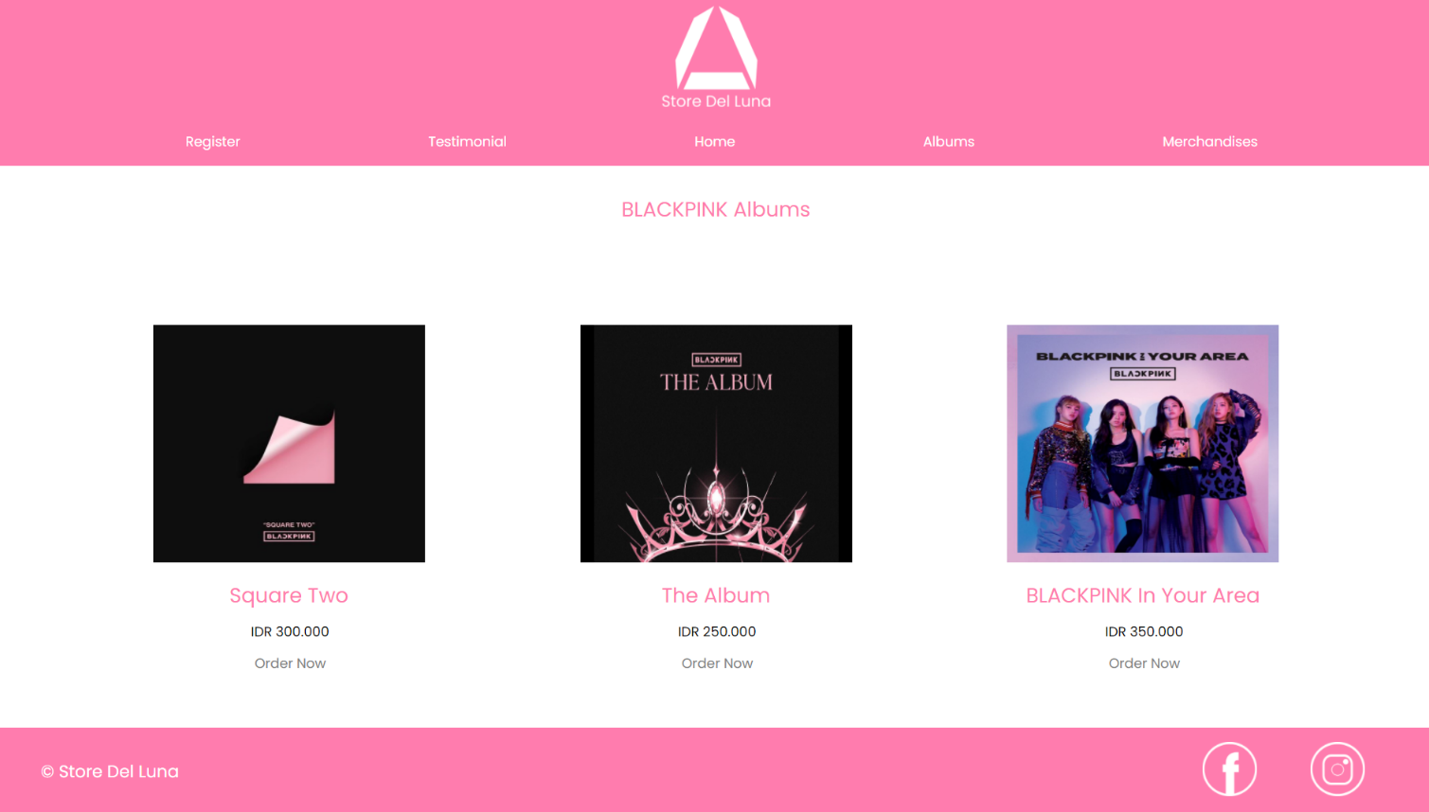

Jika user memilih salah satu dari artis tersebut, akan ditampilkan list album seperti ini.

1. **Merchandises**

Pada page ini, user dapat melihat beberapa merchandise dari artis yang tersedia.

1. **Merchandises List**

Jika user memilih salah satu dari artis tersebut, akan ditampilkan list merchandise seperti ini.

* Reference
* Images

<https://www.google.com/url?sa=i&url=https%3A%2F%2Fwww.pramborsfm.com%2Fentertainment%2Fseluruh-member-bts-dikabarkan-akan-jalani-wamil-bersama-pada-2022&psig=AOvVaw32Y5FYsijRRWXmjTj7Kyp3&ust=1624167380592000&source=images&cd=vfe&ved=0CAoQjRxqFwoTCPjjuZD9ovECFQAAAAAdAAAAABAY>

<https://www.google.com/url?sa=i&url=https%3A%2F%2Fwww.suara.com%2Fentertainment%2F2020%2F06%2F01%2F164000%2Fkabar-baik-3-member-blackpink-siap-debut-solo-susul-jennie%3Fpage%3Dall&psig=AOvVaw39YfCqP27XyeZtoynHG1x2&ust=1624167456027000&source=images&cd=vfe&ved=0CAoQjRxqFwoTCPjx77T9ovECFQAAAAAdAAAAABAD>

<https://www.google.com/url?sa=i&url=https%3A%2F%2Fkumparan.com%2Fberita-kpop%2Fexo-punya-sederet-reality-show-berikut-ini-sudah-nonton-1uOp2TYght1&psig=AOvVaw2tdiH7Bhy36z5-0OlpEZ2O&ust=1624167484749000&source=images&cd=vfe&ved=0CAoQjRxqFwoTCNjevsP9ovECFQAAAAAdAAAAABAJ>

<https://www.google.com/search?q=blackpink+in+your+area&safe=strict&sxsrf=ALeKk0376B-5Ayy-jWOwtnhtudMwM1NGXw:1624113206288&tbm=isch&source=iu&ictx=1&fir=hSxyesxb5XLffM%252ChmJdMu3mcdxGaM%252C%252Fg%252F11fhvx8yr3&vet=1&usg=AI4_-kSHDwcfsbBYIs0z9eUF6WrgIjcTqg&sa=X&ved=2ahUKEwiY5_CV9aPxAhUHVH0KHckmCMsQ_B16BAgvEAI#imgrc=hSxyesxb5XLffM>

<https://www.google.com/search?q=blackpink+square+two&safe=strict&sxsrf=ALeKk03fu4S9Givlp7T04n0yllXl5J2tOA:1624113259504&tbm=isch&source=iu&ictx=1&fir=hsjbDcC6fqji1M%252CwjCMZpiM4D835M%252C%252Fg%252F11c5g9tmkq&vet=1&usg=AI4_-kS141cZYPY90mXQbPY-7TvBEoE0QQ&sa=X&ved=2ahUKEwiTgqGv9aPxAhUZT30KHaVnDq8Q_B16BAgqEAI#imgrc=hsjbDcC6fqji1M>

<https://www.google.com/url?sa=i&url=https%3A%2F%2Fwww.pinkvilla.com%2Fentertainment%2Fhollywood%2Fblackpink-album-lisa-ros-jisoo-and-jennies-debut-studio-album-release-date-552729&psig=AOvVaw3FoYeqg0itEpDm_etMguds&ust=1624199784314000&source=images&cd=vfe&ved=0CAoQjRxqFwoTCJje_O71o_ECFQAAAAAdAAAAABAI>

<https://www.google.com/url?sa=i&url=https%3A%2F%2Fsoundcloud.com%2Fuser-680878453%2Fsets%2Ffull-album-blackpink-square&psig=AOvVaw3xKX-m5VbYP3fA-W_OnORX&ust=1624199862694000&source=images&cd=vfe&ved=0CAoQjRxqFwoTCOifrZH2o_ECFQAAAAAdAAAAABAS>

<https://www.google.com/url?sa=i&url=https%3A%2F%2Fblack-pink.fandom.com%2Fwiki%2FBLACKPINK_In_Your_Area_(album)&psig=AOvVaw3xIo1Z1u_3S55CI5tW9D8L&ust=1624199958431000&source=images&cd=vfe&ved=0CAoQjRxqFwoTCIiv0r72o_ECFQAAAAAdAAAAABAD>

<https://www.ranker.com/list/best-bts-albums/ranker-music>

<https://www.google.com/url?sa=i&url=https%3A%2F%2Fibighit.com%2Fbts%2Feng%2Fdiscography%2Fdetail%2Fdark_and_wild.php&psig=AOvVaw0Fxp5yLEZCQESqWNZGHPdJ&ust=1624202627019000&source=images&cd=vfe&ved=0CAoQjRxqFwoTCPDHrriApPECFQAAAAAdAAAAABAJ>

<https://thebiaslist.com/2018/09/15/the-top-five-best-albums-by-exo/>

<https://www.google.com/url?sa=i&url=https%3A%2F%2Fhot.detik.com%2Fkpop%2Fd-4719960%2Ffakta-menarik-twice-yang-baru-luncurkan-lagu-feel-special&psig=AOvVaw1Ac6sbe_LU31CD_eZ1pVY9&ust=1624242585739000&source=images&cd=vfe&ved=0CAoQjRxqFwoTCPi886SVpfECFQAAAAAdAAAAABAI>

<https://www.google.com/url?sa=i&url=https%3A%2F%2Fbts.fandom.com%2Fwiki%2FSuga&psig=AOvVaw1GoVlymnjvtXSOpmnGB5ju&ust=1624242535961000&source=images&cd=vfe&ved=0CAoQjRxqFwoTCKj6npyVpfECFQAAAAAdAAAAABAJ>

<https://www.google.com/url?sa=i&url=https%3A%2F%2Fhot.liputan6.com%2Fread%2F3945514%2F5-fakta-menarik-red-velvet-yang-bakal-sapa-penggemar-indonesia-pekan-depan&psig=AOvVaw1GGi7h21Wh_cvmjmd7-9UI&ust=1624242510521000&source=images&cd=vfe&ved=0CAoQjRxqFwoTCMil7IGVpfECFQAAAAAdAAAAABAT>

<https://www.google.com/url?sa=i&url=https%3A%2F%2Fwww.pinterest.com%2Fpin%2F669066088367804877%2F&psig=AOvVaw3GXdaqknSr6GBiPZanyUcz&ust=1624242972384000&source=images&cd=vfe&ved=0CAoQjRxqFwoTCMj38uKWpfECFQAAAAAdAAAAABAb>

<https://www.google.com/url?sa=i&url=https%3A%2F%2Fwww.pinterest.com%2Fpin%2F575968239839156853%2F&psig=AOvVaw3GXdaqknSr6GBiPZanyUcz&ust=1624242972384000&source=images&cd=vfe&ved=0CAoQjRxqFwoTCMj38uKWpfECFQAAAAAdAAAAABAh>

<https://www.google.com/url?sa=i&url=https%3A%2F%2Fredvelvet-jp.net%2Fen%2Fgoods%2Fdetail.php%3Fid%3D1001628&psig=AOvVaw3GXdaqknSr6GBiPZanyUcz&ust=1624242972384000&source=images&cd=vfe&ved=0CAoQjRxqFwoTCMj38uKWpfECFQAAAAAdAAAAABAn>

<https://www.google.com/url?sa=i&url=https%3A%2F%2Fshopee.co.id%2FEDDMAYR--Merchandise-Kaos-BTS-Suga--SUGAR-Oversized-T-Shirt-%2528Kaos-Min-Yoongi%2529-i.188297793.8236142596&psig=AOvVaw1m_5veXu8LdiSH43cDJ_-M&ust=1624242967387000&source=images&cd=vfe&ved=0CAoQjRxqFwoTCMCJ-NSYpfECFQAAAAAdAAAAABAD>

<https://www.google.com/url?sa=i&url=https%3A%2F%2Fbts-2020.blogspot.com%2F1971%2F01%2Fbts-hoodie-suga.html&psig=AOvVaw1m_5veXu8LdiSH43cDJ_-M&ust=1624242967387000&source=images&cd=vfe&ved=0CAoQjRxqFwoTCMCJ-NSYpfECFQAAAAAdAAAAABAP>

<https://www.google.com/url?sa=i&url=https%3A%2F%2Fwww.amazon.com%2FOfficial-Bangtan-Boys-Merchandise-Baseball%2Fdp%2FB0819VD5J7&psig=AOvVaw1m_5veXu8LdiSH43cDJ_-M&ust=1624242967387000&source=images&cd=vfe&ved=0CAoQjRxqFwoTCMCJ-NSYpfECFQAAAAAdAAAAABAV>

<https://www.google.com/url?sa=i&url=https%3A%2F%2Fwww.aliexpress.com%2Fi%2F4000456587517.html&psig=AOvVaw00n14U9wSY4deFsTb6znvK&ust=1624243882158000&source=images&cd=vfe&ved=0CAoQjRxqFwoTCMi_uY6apfECFQAAAAAdAAAAABAN>

<https://www.google.com/url?sa=i&url=https%3A%2F%2Fwww.lazada.com.ph%2Fproducts%2Ftwice-jacket-with-hood-i604302824.html&psig=AOvVaw2U7J5XE_3YYvCop-j6as3o&ust=1624243919148000&source=images&cd=vfe&ved=0CAoQjRxqFwoTCMDWkqKapfECFQAAAAAdAAAAABAD>

<https://www.google.com/url?sa=i&url=https%3A%2F%2Fshopee.co.id%2F%25F0%259F%2592%25AETWICE-bag-cartoon-Q-version-backpack-i.54798871.1501525450&psig=AOvVaw31rKFDdSophtu_qHzUTUDc&ust=1624243947844000&source=images&cd=vfe&ved=0CAoQjRxqFwoTCIDL3a2apfECFQAAAAAdAAAAABAD>

* Font

<https://fonts.google.com/specimen/Poppins?query=poppins>

* Group Member

Group 12 – PS01

* <2301892925> – <Jeremia Noel>
* < 2301940880> – < Julian Jeremy Roberto Luntungan>
* < 2301882376> – < Ray Rizy Yoseph>